SIT???

UNIT NAME

This will be the cover of your portfolio…make it nicer than this! Include unit name, your name, student id…then delete this text!

STUDENT NAME

STUDENT ID

Learning Summary Report

Self-Assessment Details

Update header with your name and ID. Then delete this box.

The following checklists provide an overview of my self-assessment for this unit.

|  |  |  |  |  |
| --- | --- | --- | --- | --- |
|  | Pass (D) | Credit (C) | Distinction (B) | High Distinction (A) |
| Self-Assessment |  |  |  |  |

Tick (use this one: ✓) the box with the grade you are applying for. Then delete this box.

Self-Assessment Statement

|  |  |
| --- | --- |
| Checklist | Included |
| Learning Summary Report |  |
| All tasks required for the target grade completed |  |
| Evidence of any additional task(s) or activities completed |  |

# Declaration

I declare that this portfolio is my individual work. I have not copied from any other student’s work or from any other source except where due acknowledgment is made explicitly in the text, nor has any part of this submission been written for me by another person.

Replace the text here. Then delete this box.

Signature: **Your Name**

Update footer with unit title and name. Then delete this box.

# Portfolio Overview

Start with a statement as

“This portfolio includes work that demonstrates that I have achieve all Unit Learning Outcomes for <SIT???> <Unit Title> to a **<Pass/Credit/Distinction/High Distinction>** level.”

Describe your learning journey – where did you start, what did you learn, where will this take you? Note the significant milestones or hurdles you overcame **that help you demonstrate your achievements.**

Provide **justifications** for why you should receive the above indicated grade… Write this for the assessment panel – tell them why you should be awarded this grade.

* For Pass: you need to indicate how you have demonstrated all Unit Learning Outcomes to an acceptable level.
* For Credit: you need to indicate how you have demonstrated all Unit Learning Outcomes to a good level.
* For Distinction: you need to indicate how you have been able to apply all of the Unit Learning Outcomes in achieving the distinction tasks.
* For High Distinction: you need to indicate how you have been able to extend beyond the material presented in the unit.

In this section, refer to your learning outcomes achievement of the tasks that you will attach in your portfolio. They are your work that evidences your justified achievements in your portfolio for evaluation. **Do not** provide your unit tasks code/outcomes/screenshots here, they will be attached by you later when you create your portfolio step by step via OnTrack. This section of the learning summary report is just a summary - Portfolio Overview.

Think of this like a cover letter to a job application. The unit learning outcomes are the job’s selection criteria **(Get the unit learning outcomes from the Unit Guide)**. Your tasks provide the evidence of how you have met these criteria. Thus, this section should be no more than two pages.

Read and then delete this text… This is where you present your justifications. See all notes in the page. This should be **no more than two pages.**

Then delete this box.

# Reflections

## The most important things I learnt:

Think about what you have learnt in this unit and reflect on what you think were key learning points, tasks, activities, etc. Did you learn what you wanted/expected to learn?

Reflect on your learning and discuss these areas. The text provided outlines what we want you to discuss in this section – this should be read and then deleted so that each reflection contains just your text.

## I feel I learnt these topics, concepts, and/or tools really well:

What things are you really confident about now?

## I found the following topics particularly challenging:

What was the most challenging part of the unit? Have you mastered those ideas, concepts, or skills now? What did you learn about yourself in how you dealt with these challenges?

## I found the following topics particularly interesting:

What was the most interesting or valuable thing you learnt from this unit? This could be related to the unit concepts, or general things you learnt about yourself.

## I still need to work on the following areas:

University is about developing lifelong learning skills. Given what you have achieved already, what is the next step for you? How will you build upon what you learnt in this unit? This could be related to the unit concepts and skills, or to personal traits you identified as needing further development.

## The things that helped me most were:

What were the most helpful/useful resources? How did they assist you with your learning?

## My progress in this unit was …:

Include a screenshot of your **progress graph** from **OnTrack**, and comment on what happened from your perspective… what does the graph say about how you approached the unit?

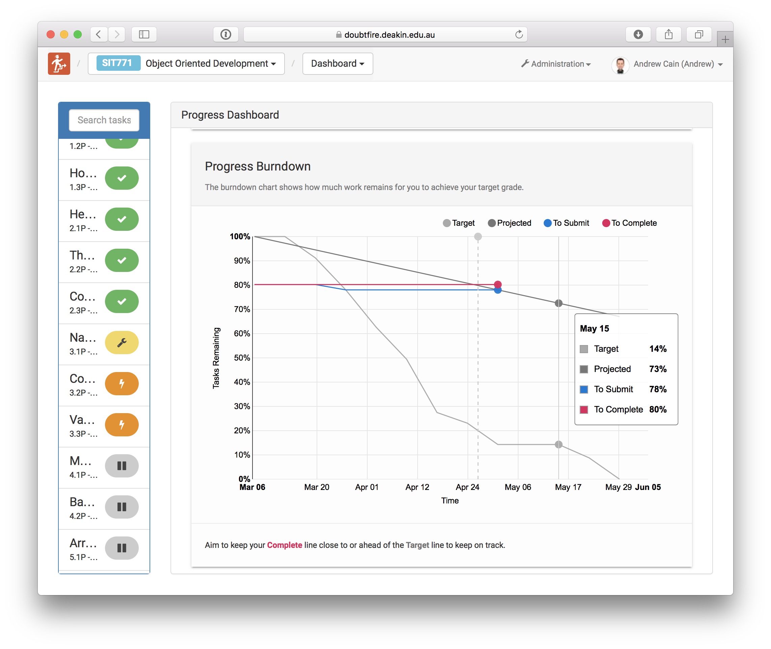

## If I did this unit again, I would do the following things differently:

Looking back, what is it that you think you could have done differently to help you achieve the most you could in this unit (both in terms of the unit concepts and skills, and in terms of personal growth). How will you approach learning in the future?

## Other…:

Adjust this heading to add any other reflections you think help you demonstrate what you got out of this unit, and how it has or will help shape you as an IT Professional.